Nurse Assistant for Disease Diagnostic

Prepared by: Abdellah El Younsi, Mahmoud Benchaabane, Mouad Bouaida & Omar Morsli, Graduate engineering students from IMT Atlantique

How care at the emergency department is organized?

In France, more than 21 million people were admitted in emergencies at hospitals in 2016 [1]. Those emergencies are often crowded, and the reception staff is often overwhelmed. The mean waiting time is greater than 2 hours for more than 50% in of the cases [2]. A great waiting time can not only result a small patient satisfaction but can also increase morbidity and mortality.

The process of admission to the emergency services takes place in 3 stages:
- A first administrative reception where the patient's identity papers are requested.
- A reception nurse asks and notes the symptoms which the patient suffers in order to direct him towards the service
- The adequate medical examination and finally the medical examination strictly speaking.

How could we improve the quality of this service?

We chose to focus on the second stage of the process. Our project aims to create a smartphone/tablet application to help reception nurses diagnose quickly the patient's illness.
Let's imagine together the following scenario: A patient arrives on Sunday evening and the emergency department is overwhelmed. The nurse in charge of the reception points him to the bad service and his time of care is considerably lengthened.

To remedy this problem: The nurse in charge of the reception will be able to inform in our application NADD: Nurse Assistant Disease Diagnostic the symptoms of which the patient suffers, and our application will return to him the illness of which the patient suffers.
Figure 1: The logo of the application
The application was designed as shown in figure 2. We have chosen to use a simple design to make it easier for nurses to use. The home page presents a list of symptoms illustrated by images.
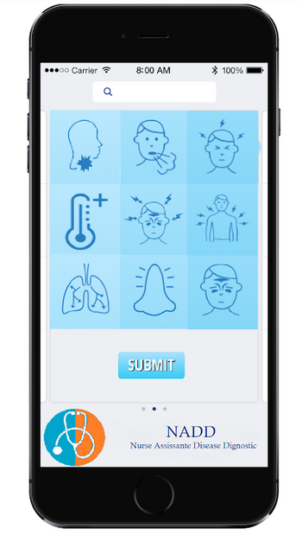
Figure 2: NADD - web application

Data is capable to give an answer to this problem!

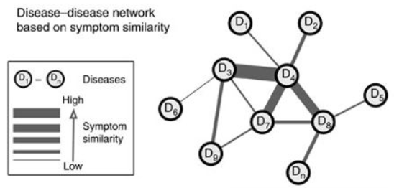
Several resources have been constructed aiming to understand the entangled relationship between diseases, often in the form of networks [3]. For example, Rzhetsky et al. [4] inferred the comorbidity links between 161 disorders from the disease history of 1.5 million patients and proposed models to estimate the genetic overlap between diseases. Hidalgo et al. [5] constructed a disease phenotypic network using comorbidity patterns from more than 30 million Medicare patients, capturing disease progression patterns, such as that patients tend to develop diseases in the network vicinity of diseases that they already have and that patients with highly interconnected diseases show higher mortality.
Figure 3: Disease network, in which nodes represent diseases and links represent symptom similarities between diseases.

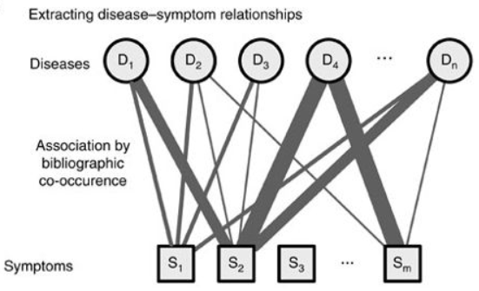
An important available resource that has been overlooked so far is the highest-level clinical phenotypes, that is, symptoms and signs (called symptoms in brief in the following). Symptoms are crucial in clinical diagnosis and treatment. For example, the major symptoms of a heart attack are pain or discomfort in the chest, arms or shoulder, jaw, neck, or back, feeling weak, light-headed or faint and shortness of breath [6]. The wide range of symptoms illustrates the interdependence of the homeostatic mechanisms, whose perturbations lead to the manifestation of a disease. Community health professionals and general practitioners derive most of their knowledge of the symptoms of individual diseases from hospital-based observation [7]. Indeed, symptoms are the most directly observable characteristics of a disease and the very basis of clinical disease classification. The elucidation of the connection between shared symptoms and shared genes or protein–protein interactions of two diseases could therefore help bridge the gap between bench-based biological discovery and bedside clinical solutions.
Figure 4: Disease–symptom relationships: The association between symptoms and diseases are based on their co-occurrence in the MeSH metadata fields of PubMed.
The comprehensive, high-quality map of disease–symptom relations can further be used as a resource helping to address important questions in the field of systems medicine, for example, the identification of unexpected associations between diseases, disease etiology research or drug design.
The figures below summarize the disparity that exists between different diseases and symptoms.
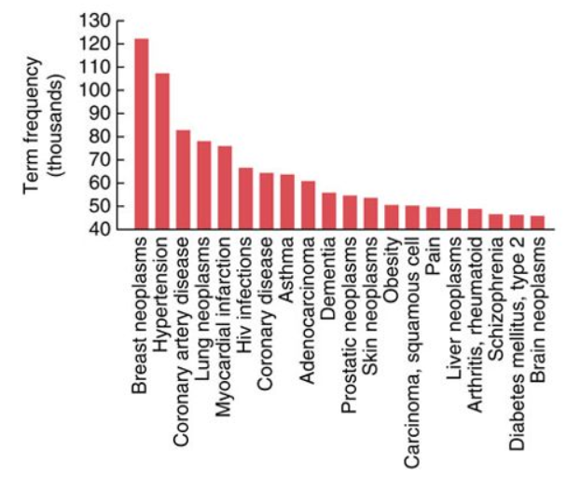
Figure 5: The twenty most frequent disease terms.

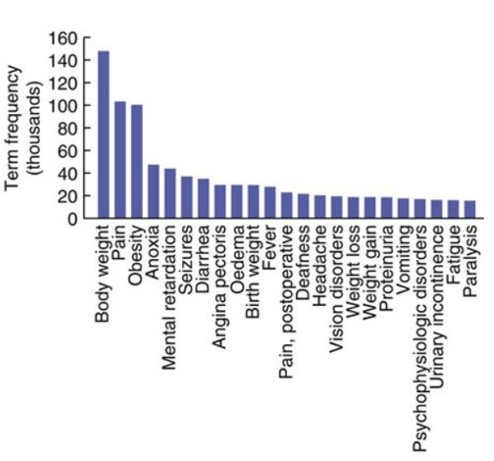
Figure 6: The top twenty symptom terms
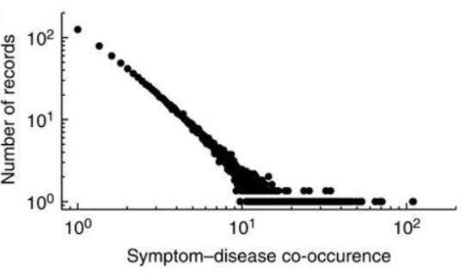
Figure 7: Symptom and disease co-occurrence distribution.

The raw data was not directly useful

To make our data understandable and adapted to our models we used One Hot Encoding transformation technique.

What is One Hot Encoding?
A one hot encoding is a representation of categorical variables as binary vectors. This first requires that the categorical values be mapped to integer values. Then, each integer value is represented as a binary vector that is all zero values except the index of the integer, which is marked with a 1.
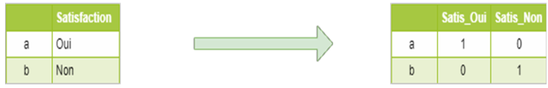
Figure 8: One-hot Encoding process

Why One Hot Encoding?
A one hot encoding allows the representation of categorical data to be more expressive. Many machine learning algorithms cannot work with categorical data directly. The categories must be converted into numbers. This is required for both input and output variables that are categorical.

From Data to Model

Before starting the training phase of the various models, the data provided should be studied in detail. The first thing to do is a principal component analysis of symptoms and study the correlation of these. This study was done on 10 symptoms for readability and it allowed to see different groups of symptoms that can be grouped together and detect the correlation between symptoms.
So before applying a model we must check that the model is not biased by the correlation between symptoms.
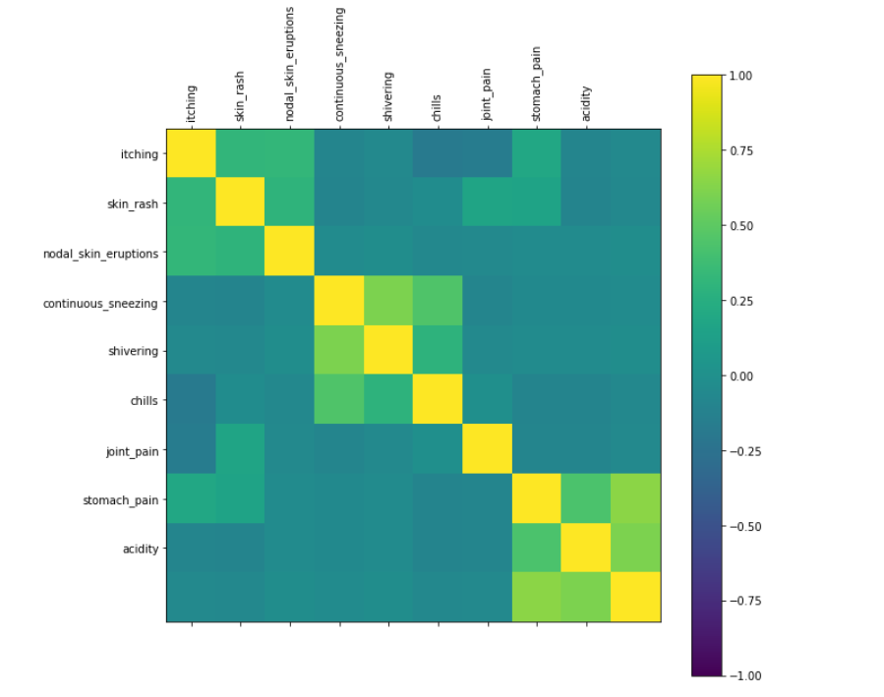
Figure 9: Heatmap, Correlation between symptoms

So, the first idea that comes to our mind is to apply the naive bayes method [8]. With the Naive Bayes we had an Accuracy of 76% and std = 22%. These bad results were expected. The data analysis that we have done showed that this method could not be applied because this method relies on the independence of the variables. So, we preferred not to reduce the symptoms by removing those that are correlated because we will lose information and in the medical field all information is valuable.
So, the second solution tested was a decision tree [9]. Data with many qualitative variables, a decision tree seems adequate to our problem.
With the decision tree we had an Accuracy of 56% and std = 17% which is normal considering the quantities of the variable’s thing that a single decision tree cannot handle.
To alleviate this problem and improve our performance we tested the Random Forest [10]. The Random Forest is used because the qualitative variables facilitate the creation of trees. This method brought an Accuracy of 98% and std = 8%.
We applied a grid search for all test models to find the best hyperparameters and applied the Leave One Out Cross Validation to validate the performance and reliability of the model.

The results are fine, but... How did the model make it?

The general or classical pipeline of a Data Science Project is to follow the CRISP-DM methodology: In order to build an application, we collect some data, analyze and preprocess it, then we build a machine learning model and make predictions which will interact directly with the application. But what if the predictions do not make any sense at all or the under-hood process that led to some predictions is not logical or incorrect. So how could one trust the model? or what are the measures to reliability?

In general, there are two main ways to measure the trust:

by building simple models: These models are easy to understand and interpret which means the underlying process could be understood by a human being and do not need any deep knowledge to comprehend. However, they do not perform well especially on large datasets.

by defining a suitable measure to your business need: accuracy, recall, precision…
These measures are sometimes overestimated and bias estimates of the real values. The famous example was the model trained in 20 newsgroups dataset. This model was trained to distinguish between Atheism and Christianity. This problem, intuitively, is supposed to be hard due to the words that are shared between the two religions. The model achieved 94% accuracy on the test dataset, which surpassed the human performance. However, when trying to understand how this model, the machine learning community noticed that it uses features which are (due to human prior knowledge) not related to the classification made. As the figure illustrates, the model predicted that the document is about Atheism (which was correct) but what pushed the model to say so is the presence of these words: Posting, Hosy, Re,Nntp which have nothing to do with Atheism.

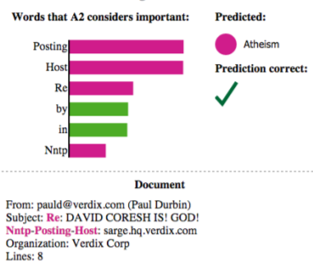
Figure 10: Highlighting the importance of each word used to get the prediction

If accuracy was the only measure of trust, we would trust this algorithm which could be in some cases a catastrophic decision.
As we can conclude, it seems interpreting the models we built is so crucial. In order to do so, we used the LIME framework [11]. The pipeline of this framework is illustrated in the figure below:
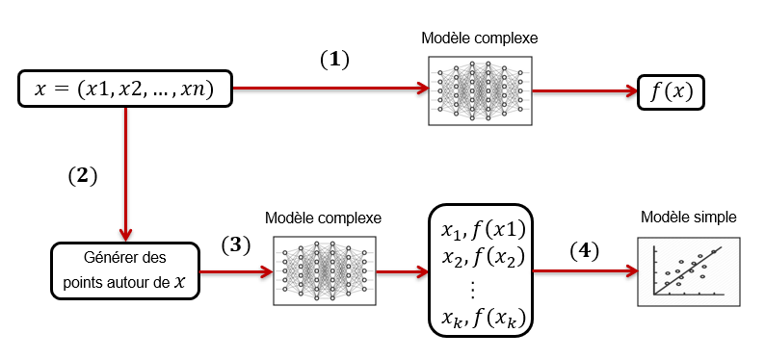
Figure 11: Different steps to explain a model with LIME

The idea is in order to interpret the complex model’s prediction at the point ,we perturb the neighborhood of and get a perturbed dataset. Then we apply the complexe model to get a labeled dataset {(,}. We fit then a locally weighted model on this dataset to approximate the complex model:
As a result, the coefficients measure the contribution of each to the final contribution.

Should we really trust this model?

Cross-validation is a widely used method to select and compare machine learning models. In general, when using the K-fold cross-validation, we try to estimate the performance of a model trained on a dataset 100*(k-1)/k% of the available data, rather than on 100% of it. So if we perform cross-validation to estimate performance, and then use a model trained on all of the data for operational use, it will perform slightly better than the cross-validation estimate suggests since having more data helps to get a better estimation of the model performance. As we can conclude, this method gives a pessimistically biased estimate of the performance especially with small databases.

Leave-one-out cross-validation (LOOCV) is a K-fold cross-validation where K is the number of samples in the dataset. This method is approximately unbiased, because the difference in size between the training set used in each fold and the entire dataset is only a single pattern [12]. See also [13].

In general, the variance in fitting the model tends to be higher if it is fitted to a small dataset, this means that 10-fold cross-validation is likely to have a high variance (as well as a higher bias) in small datasets than for LOOCV.
To wrap up, K-fold cross-validation can have not only high bias but also high variance issues as well. Therefore, LOOCV was our choice to measure our model’s performance.

References

[1] Près de 21 millions de passages aux urgences en 2016. Available in: https://www.lexpress.fr/actualite/societe/pres-de-21-millions-de-passages-aux-urgences-en-2016_2020353.html.
[2] Boisguérin, B., & Valdelièvre, H. (2014). Urgences: la moitié des patients restent moins de deux heures, hormis ceux maintenus en observation. Etudes et Résultats, 889.
[3] Barabasi, A. L., Gulbahce, N. & Loscalzo, J. Network medicine: a network-based approach to human disease. Nat. Rev. Genet. 12, 56–68 (2011).
[4] Rzhetsky, A., Wajngurt, D., Park, N. & Zheng, T. Probing genetic overlap among complex human phenotypes. Proc. Natl Acad. Sci. USA 104, 11694–11699 (2007).
[5] Hidalgo, C. A., Blumm, N., Barabasi, A. L. & Christakis, N. A. A dynamic network approach for the study of human phenotypes. PLoS. Comput. Biol. 5, e1000353 (2009).
[6] Little, R. A. et al. Plasma catecholamines in the acute phase of the response to myocardial infarction. Arch. Emerg. Med. 3, 20–27 (1986).
[7] Knottnerus, J. A. The effects of disease verification and referral on the relationship between symptoms and diseases. Med. Decis. Making 7, 139–148 (1987).
[8] Taheri, S., & Mammadov, M. (2013). Learning the naive Bayes classifier with optimization models. International Journal of Applied Mathematics and Computer Science, 23(4), 787-795.
[9] Gupta, B., Rawat, A., Jain, A., Arora, A., & Dhami, N. (2017). Analysis of various decision tree algorithms for classification in data mining. Int J Comput Appl, 8, 15-9.
[10] Breiman, L. (2001). Random forests. Machine learning, 45(1), 5-32.
[11] Tulio Ribeiro, Marco & Singh, Sameer & Guestrin, Carlos. (2016). “Why Should I Trust You?”: Explaining the Predictions of Any Classifier. 97-101. 10.18653/v1/N16-3020.
[12] Luntz, Aleksandr, and Viktor Brailovsky. "On estimation of characters obtained in statistical procedure of recognition." Technicheskaya Kibernetica 3.6 (1969: 6-12.
[13] Estimation of Error Rates in Discriminant Analysis Peter A. Lachenbruch and M. Ray Mickey Technometrics Vol. 10, Iss. 1,1968.

